A PROJECT REPORT

CAMWORD

Submitted by

HARDIK PATEL
KISHAN PATEL
ZOEB CHHATRIWALA

In fulfillment for the award of the degree
Of
BACHELOR OF ENGINEERING
In
Computer Science and Engineering



Parul Institute of Engineering and Technology, Vadodara

Gujarat Technological University, Ahmedabad

APRIL 2015

Parul Institute of Engineering and Technology

Computer Science and Technology

CERTIFICATE

Date:

This is to certify that the project entitled “CamWord” has been carried out by Hardik Patel, Kishan Patel and Zoeb Chhatriwala under my guidance in fulfillment of the degree of Bachelor of Engineering in Computer Science and Engineering (7t_{h} Semester/8t_{h} Semester) of Gujarat Technological University, Ahmed-during the academic year 2013-14.

Guide: Internal Guide
Mrs. Riddhi Patel

Head of the Department

Acknowledgment

It is very difficult to express our feelings and we feel short of words for those who have contributed a lot in our training and provided their invaluable cooperation to us. Many people have helped, provided direction as well as technical information and it is our pleasure to acknowledge our debt to the many people involved directly or indirectly involved in development of this project.

Our deep sense of gratitude is extended to Mrs. Riddhi Patel (Asst.Professor, CSE department) whose continuous encouragement, suggestion, and constructive criticism have been invaluable assets throughout the project work.

We are also thankful to Mr. Harshal Shah (HOD, CSE Department) and Parul Institute of Engineering and Technology for helping us to build our career and laying down a platform, which will help us to build a career in software industry.

We would be unjust not to mention the help forwarded to us by our friends who were ever ready to support us.Finally, we express our sincere gratitude to our parents who have encouraged us to try our best to carry out the project.

TABLE OF CONTENTS

TITLE PAGE 1
CERTIFICATE PAGE 2
ACKNOWLEDGEMENT 3
TABLE OF CONTENTS 4
LIST OF FIGURES 7
ABSTRACT 8

CHAPTER 1 INTRODUCTION 9
1.1 Project Profile 9 1.2 Project Definition 10
1.3 Scope 10
1.4 Modular Description 10
1.5 Objectifies 11
1.6 Tools and Technology 11
1.7 Literature Review 12
CHAPTER 2 BRIEF HISTORY OF WORK 13
2.1 Introduction 13
2.2 Detailed Description of Topic 16

2.3 Security 21
2.4 Advantages 21
CHAPTER 3 Project Analysis 23
3.1 UML Diagrams
3.1.1 Use Case Diagram 23
3.2 Sequence Diagram 24
3.2.1 Sequence Diagram for System 24
3.2.2 Sequence Diagram for Character Recognition 25
3.2.3 Sequence Diagram for Speech Recognition 26
3.2.4 Sequence Diagram for Spell Checking 26
3.3 E - R Diagram 27
3.4 Class Diagram 28
3.5 Activity Diagram 29
3.5.1 Activity Diagram for System 29
3.5.2 Activity Diagram for Character Recognition 30
3.5.3 Activity Diagram for Speech Recognition 31
3.5.4 Activity Diagram for Spell Checking 32
3.6 GUI Snapshots 33

CHAPTER 4 REQUIREMENT ANALYSIS 35
4.1 User Characteristics 36
4.1 Hardware Requirement 36
4.3 Requirement for Development 37
4.3.1 Functional Requirement 37
4.3.2 Non-Functional Requirement 37

CHAPTER 5 CODING, TESTING AND IMPLEMENTATION 38
5.1 Coding Standards 38
5.2 Software Testing 51
5.2.1 Overview of Testing Methods 51
5.2.2 Modules of Testing 52
5.2.3 Testing Strategy 55
CONCLUSION 57
REFERENCES 58

LIST OF FIGURES
SR.NO NAME PAGE NO

Figure 3.1 Use Case Diagram 23
Figure 3.2 Sequence Diagram 24
Figure 3.3 E-R Diagram 27
Figure 3.4 Class Diagram 28
Figure 3.5 Activity Diagram 29

ABSTRACT
Our project is an Artificial Intelligence based application that uses character and speech recognition to identify word and define or translate on user request. This will save time of the user which he/she waste in typing and provide user with enhanced experience of smartphones technology.

Our project is developed in Android Programming Language and its features Character recognition and Speech recognition uses specific functional engines to obtain output. Our application can be used to identify a word from a document or a user voice.

When we come in contact with a word which we don’t know the meaning or translation while reading any document then we take a smartphone in hand and type a word in dictionary or translation application. Our application will save the time of the user as the user can just scan the word with its camera or get it recognized by voice and our application would provide the solution. We would also add an additional features that check user entered word for its spelling.

Chapter: 1
Introduction to Project

1.1 Project Profile:

Project Name : CamWord

Project Type : Android application.

Development Team: Hardik Patel, Kishan Patel, Zoeb Chhatriwala

Internal Guide : Ms. Riddhi Patel (Asst. Professor) CSE Dept.
P.I.E.T

Tools &Technology: Eclipse SDK (Android),

Back-End tools : Google API, Tesseract Engine API

1.2 Project Definition:

Our project is an Android Based Application that uses Character recognition and Voice recognition to identify a word and then translate or define on user's request. This Application can be used to identify a word from a document or a user voice.

When we come in contact with a word which we don’t know the meaning or translation while reading any document then we take a smartphone in hand and type a word in dictionary or translation application. Our application will save the time of the user as the user can just scan the word with its camera or get it recognition by voice and our application would provide the solution.

1.3 Scope of Project:
- Integration: Three different application or module is integrated into one fine app.
- Fast to Use: As this application saves user time by character recognized and speech recognized word identification.
- Accessibility: In this application, User can easily access functionalities of application and naïve user can also easily learn how to use.
-

1.4 Modular Description:
Character Recognition: Word is recognized form the image capture from camera. This word is defined or translated based on user preference.
Speech Recognition: After activating this module user can just speak the word whose definition user want after doing predefined activating activity. The module will provide the definition of the word in a toast message.
Spell Check: This is a Module that checks the user word spelling and correct it.

1.5 Objectives:

The main objective of this application is to save the time of the user as typing a word every time is annoying task. Also the objective of this application is to give comfort and at ease to user.

1.6 Tools & Technology:

Tesseract API:
Tesseract API (Application Programming Interface) which implements Tesseract engine for OCR (Optical Character Recognition).
Speech Recognition API:
Speech Recognition API is an API (Application Programming Interface) which implements Speech Recognition engine.
Eclipse IDE:
Eclipse is a multi-language Integrated development environment (IDE) comprising a base workspace and an extensible plug-in system for customizing the environment. It is written mostly in Java. It can be used to develop applications in Java and, by means of various plug-ins, other programming languages Development environments include the Eclipse Java development tools (JDT) for Java and Eclipse PDT for PHP, among others.
Eclipse SDK is free and open source software. It was one of the first IDEs to run under GNU Class path and it runs without problems under IcedTea.

1.7 Literature Review:

1.7.1 Android
Android is Mobile Platform developed by Google. Developers create applications in Java on the platform. It includes some important features like 3D graphics, Media support for common audio, video, and still image formats (MPEG4, H.264, MP3, AAC, AMR, JPG, PNG, GIF), GSM Telephony, Bluetooth, 3G, Wi-Fi, GPS depending on hardware capability of mobile devices.
Highlights of Android
Firstly, Android is open-source platform. Secondly, Android enables reuse of components. For example, there is one component for editing text files in one application; other applications can make use of the component as needed, of course, the application has released the permission that other applications can use it. Thirdly, Android can be native access to Google map infrastructure. And it supports GPS localization. Fourthly, its network can work in the way of Bluetooth, 3G or Wi-Fi. Finally, it provides Widgets classes and Layout classes for designing UI.
Application Fundamentals
The part presents main concepts for application development. There are four types of application components: Activity, Service, Broadcast Receivers, and Content Provider. Android application may consist of one or several of these components types.

Chapter 2:
Brief history of work

Introduction to the Android
Android is a software stack for mobile devices that includes an operating system, middleware and key applications.Android is a software platform and operating system for mobile devices based on the Linux operating system and developed by Google and the Open Handset Alliance. It allows developers to write managed code in a Java-like language that utilizes Google-developed Java libraries, but does not support programs developed in native code.

The unveiling of the Android platform on 5 November 2007 was announced with the founding of the Open Handset Alliance, a consortium of 34 hardware, software and telecom companies devoted to advancing open standards for mobile devices. When released in 2008, most of the Android platform will be made available under the Apache free-software and open-source license.

2.1.1 Features
Application Framework
It is used to write applications for Android. Unlike other embedded mobile environments, Android applications are all equal, for instance, an applications which come with the phone are no different than those that any developer writes.The framework is supported by numerous open source libraries such as openssl, SQLite and libc. It is also supported by the Android core libraries. From the point of security, the framework is based on UNIX file system permissions that assure applications have only those abilities that mobile phone owner gave them at install time.

Dalvik Virtual Machine
It is extremely low-memory based virtual machine, which was designed especially for Android to run on embedded systems and work well in low power situations. It is also tuned to the CPU attributes. The Dalvik VM creates a special file format (.DEX) that is created through build time post processing. Conversion between Java classes and .DEX format is done by included “dx” tool.
Integrated Browser
Google made a right choice on choosing WebKit as open source web browser. They added a two pass layout and frame flattening. Two pass layout loads a page without waiting for blocking elements, such as external CSS or external JavaScript and after a while renders again with all resources downloaded to the device. Frame flattening converts founded frames into single one and loads into the browser. These features increase speed and usability browsing the internet via mobile phone.
Optimized Graphics
As Android has 2D graphics library and 3D graphics based on OpenGL ES 1.0, possibly we will see great applications like Google Earth and spectacular games like Second Life, which come on Linux version. At this moment, the shooting legendary 3D game Doom was presented using Android on the mobile phone.
SQLite
Extremely small (~500kb) relational database management system, which is integrated in Android. It is based on function calls and single file, where all definitions, tables and data are stored. This simple design is more than suitable for a platform such as Android.

Handset Layouts
The platform is adaptable to both larger, VGA, 2D graphics library, 3D graphics library based on OpenGL ES 1.0 specifications, traditional smart phone layouts. An underlying 2D graphics engine is also included. Surface Manager manages access to the display subsystem and seamlessly composites 2D and 3D graphic layers from multiple applications
Data Storage
SQLite is used for structured data storage .SQLite is a powerful and lightweight relational database engine available to all applications.
Connectivity
Android supports a wide variety of connectivity technologies including GSM, CDMA, Bluetooth, EDGE, EVDO, 3G and Wi-Fi.
Messaging
SMS, MMS, and XMPP are available forms of messaging including threaded text messaging.
Web Browser
The web browser available in Android is based on the open-source WebKit application framework. It includes LibWebCore which is a modern web browser engine which powers both the Android browser and an embeddable web view.
Java Virtual Machine
Software written in Java can be compiled into Dalvik byte codes and executed in the Dalvik virtual machine, which is a specialized VM implementation designed for mobile device use, although not technically a standard Java Virtual Machine.

Media Support
Android will support advanced audio/video/still media formats such as MPEG-4, H.264, MP3, and AAC, AMR, JPEG, PNG, GIF.
Additional Hardware Support
Android is fully capable of utilizing video/still cameras, touch screens, GPS, compasses, accelerometers, and accelerated 3D graphics.

  - Detailed Description of the topic
2.2.1 Architecture
The following diagram shows the major components of the Android operating system. Each section is described in more detail below.
Linux Kernel
Android Architecture is based on Linux 2.6 kernel. It helps to manage security, memory management, process management, network stack and other important issues. Therefore, the user should bring Linux in his mobile device as the main operating system and install all the drivers required in order to run it. Android provides the support for the Qualcomm MSM7K chipset family. For instance, the current kernel tree supports Qualcomm MSM 7200A chipsets, but in the second half of 2008 we should see mobile devices with stable version Qualcomm MSM 7200, which includes major features:
- WCDMA/HSUPA and EGPRS network support
- Bluetooth 1.2 and Wi-Fi support
- Digital audio support for mp3 and other formats
- Support for Linux and other third-party operating systems
- Java hardware acceleration and support for Java applications
- Qcamera up to 6.0 megapixels
- gpsOne – solution for GPS
- and lots of other.
Library
In the next level there are a set of native libraries written in C/C++, which are responsible for stable performance of various components. For example, Surface Manager is responsible for composing different drawing surfaces on the mobile screen. It manages the access for different processes to compose 2D and 3D graphic layers.OpenGL ES and SGL make a core of graphic libraries and are used accordingly for 3D and 2D hardware acceleration.

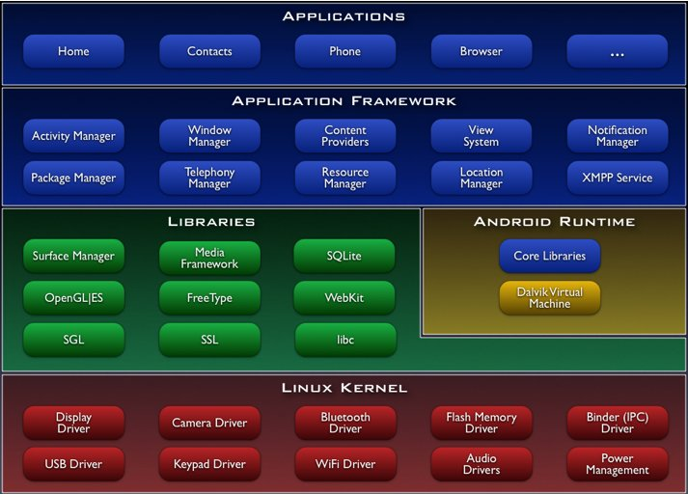

Figure 2.1 Architecture of the Android ^{[2]}

Android Runtime
At the same level there is Android Runtime, where the main component Dalvik Virtual Machine is located. It was designed specifically for Android running in limited environment, where the limited battery, CPU, memory and data storage are the main issues. Android gives an integrated tool “dx”, which converts generated byte code from .jar to .dex file, after this byte code becomes much more efficient to run on the small processors.

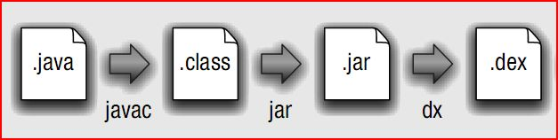
Figure 2.2 Android Runtime
As the result, it is possible to have multiple instances of Dalvik virtual machine running on the single device at the same time. The Core libraries are written in Java language and contains of the collection classes, the utilities, IO and other tools.
    - Application Framework
After that, there is Application Framework, written in Java language. It is a toolkit that all applications use, ones which come with mobile device like Contacts or SMS box, or applications written by Google and any Android developer. It has several components.

The Activity Manager manages the life circle of the applications and provides a common navigation back stack for applications, which are running in different processes. The Package Manager keeps track of the applications, which are installed in the device. The Windows Manager is Java programming language abstraction on the top of lower level services that are provided by the Surface Manager.
The Telephony Manager contains of a set of API necessary for calling applications.
- Application Layer
At the top of Android Architecture we have all the applications, which are used by the final user. By installing different applications, the user can turn his mobile phone into the unique, optimized and smart mobile phone. All applications are written using the Java programming language.
2.2.2 AndroidManifest.xml
The AndroidManifest.xml file is the control file that tells the system what to do with all the top-level components (specifically activities, services, intent receivers, and content providers described below) you've created. For instance, this is the "glue" that actually specifies which Intents your Activities receive.
2.2.3 Application life cycle
In Android, every application runs in its own process, which gives better performance in security, protected memory and other benefits. Therefore, Android is responsible to run and shut down correctly these processes when it is needed.
It is important that application developers understand how different application components (in particular Activity, Service, and BroadcastReceiver) impact the lifetime of the application's process. Not using these components correctly can result in the system killing the application's process while it is doing important work.
- It is running an Activity at the top of the screen that the user is interacting with (its onResume() method has been called).
- It has a BroadcastReceiver that is currently running (its BroadcastReceiver.onReceive() method is executing).
- It has a Service that is currently executing code in one of its callbacks (Service.onCreate(), Service.onStart(), or Service.onDestroy()).
There will only ever be a few such processes in the system, and these will only be killed as a last resort if memory is so low that not even these processes can continue to run. Generally, at this point, the device has reached a memory paging state, so this action is required in order to keep the user interface responsive.
A visible process is one holding an Activity that is visible to the user on-screen but not in the foreground (its onPause() method has been called). This may occur, for example, if the foreground Activity is displayed as a dialog that allows the previous Activity to be seen behind it. Such a process is considered extremely important and will not be killed unless doing so is required to keep all foreground processes running.

A service process is one holding a Service that has been started with the startService() method. Though these processes are not directly visible to the user, they are generally doing things that the user cares about (such as background mp3 playback or background network data upload or download), so the system will always keep such processes running unless there is not enough memory to retain all foreground and visible process.

2.2.4 Application framework
Developers have full access to the same framework APIs used by the core applications. The application architecture is designed to simplify the reuse of components; any application can publish its capabilities and any other application may then make use of those capabilities (subject to security constraints enforced by the framework). This same mechanism allows components to be replaced by the user.
Underlying all applications is a set of services and systems, including:
- A rich and extensible set of Views that can be used to build an application, including lists, grids, text boxes, buttons, and even an embeddable web browser.
- Content Providers that enable applications to access data from other applications (such as Contacts), or to share their own data.
- A Resource Manager, providing access to non-code resources such as localized strings, graphics, and layout files.
- A Notification Manager that enables all applications to display custom alerts in the status bar.

2.2.5 Library
- Android includes a set of C/C++ libraries used by various components of the Android system. These capabilities are exposed to developers through the Android application framework. Some of the core libraries are listed below:
- System C library - a BSD-derived implementation of the standard C system library (libc), tuned for embedded Linux-based devices
- Media Libraries - based on PacketVideo'sOpenCORE; the libraries support playback and recording of many popular audio and video formats, as well as static image files, including MPEG4, H.264, MP3, AAC, AMR, JPG, and PNG
- Surface Manager - manages access to the display subsystem and seamlessly composites 2D and 3D graphic layers from multiple applications .
- LibWebCore - a modern web browser engine which powers both the Android browser and an embeddable web view

2.3 Security
Android mobile phone platform is going to be more secure than Apple’s iPhone or any other device in the long run. There are several solutions nowadays to protect Google phone from various attacks. One of them is security vendor McAfee, a member of Linux Mobile (LiMo) Foundation. This foundation joins particular companies to develop an open mobile-device software platform. Many of the companies listed in the LiMo Foundation have also become members of the Open Handset Alliance (OHA).
2.4 Advantages
- Open - Android allows you to access core mobile device functionality through standard API calls.
- All applications are equal - Android does not differentiate between the phone's basic and third-party applications -- even the dialer or home screen can be replaced.
- Breaking down boundaries - Combine information from the web with data on the phone -- such as contacts or geographic location -- to create new user experiences.
- Fast and easy development - The SDK contains what you need to build and run Android applications, including a true device emulator and advanced debugging tools.

Disadvantages
- Security - Making source code available to everyone inevitably invites the attention of black hat hackers.
- Open Source - A disadvantage of open-source development is that anyone can scrutinize the source code to find vulnerabilities and write exploits.
- Login - Platform doesn't run on an encrypted file system and has a vulnerable log-in.
- Incompetence - Google’s dependence on hardware and carrier partners puts the final product out of their control.

Chapter 3:
Project Analysis

Systems design is the process of defining the architecture, components, modules, interfaces, and data for a system to satisfy specified requirements. Systems design could be seen as the application of systems theory to product development. There is some overlap with the disciplines of systems analysis, systems architecture and systems engineering.

3.1 UML Diagrams

3.1.1 Use Case Diagram

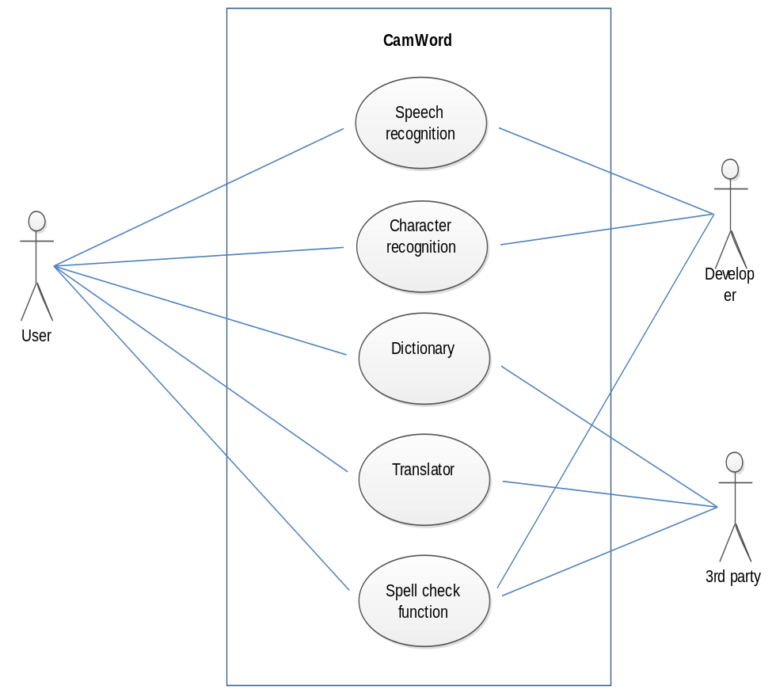

Figure: 3.1 Use Case Diagram of Scheduling Module

3.2 Sequence Diagram:

3.2.1 Sequence Diagram for System
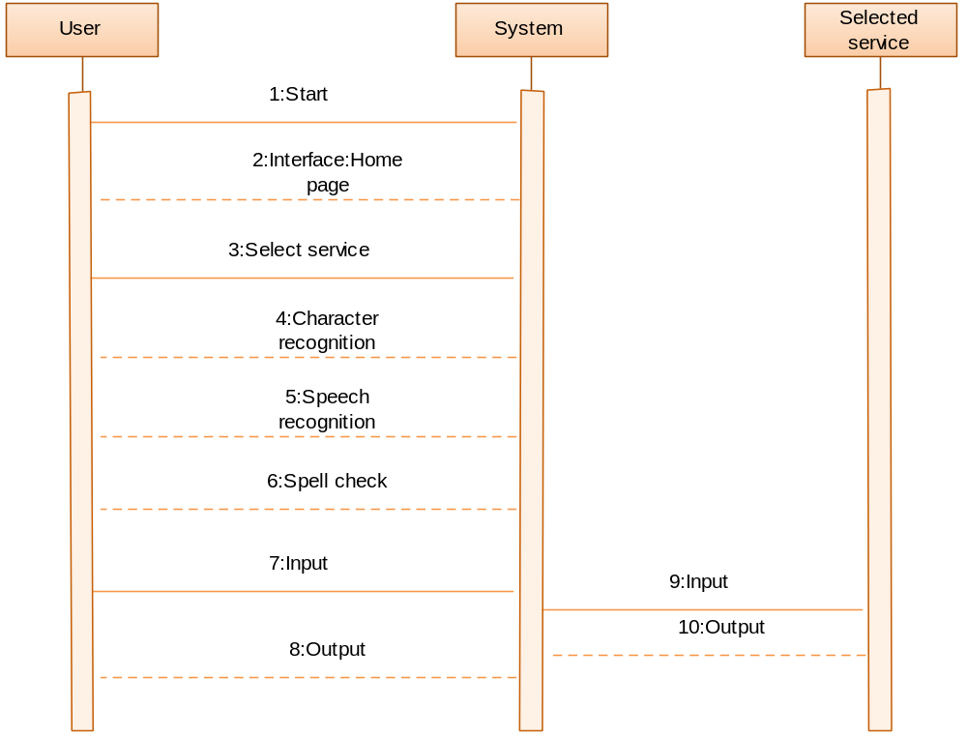

Figure 3.2 Sequence Diagram for System

3.2.2 Sequence Diagram for Character Recognition
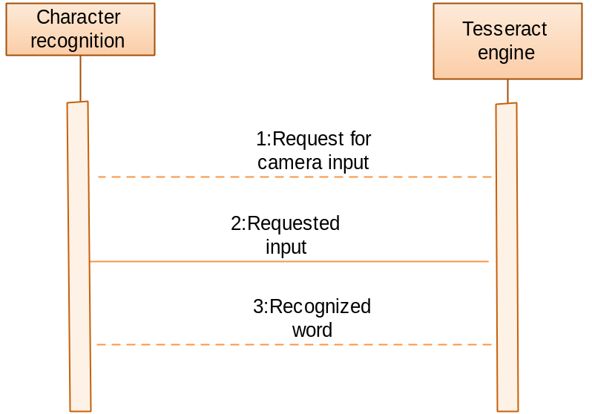
Figure: 3.3 Sequence Diagram for Character Recognition

3.2.3 Sequence Diagram for Speech Recognition
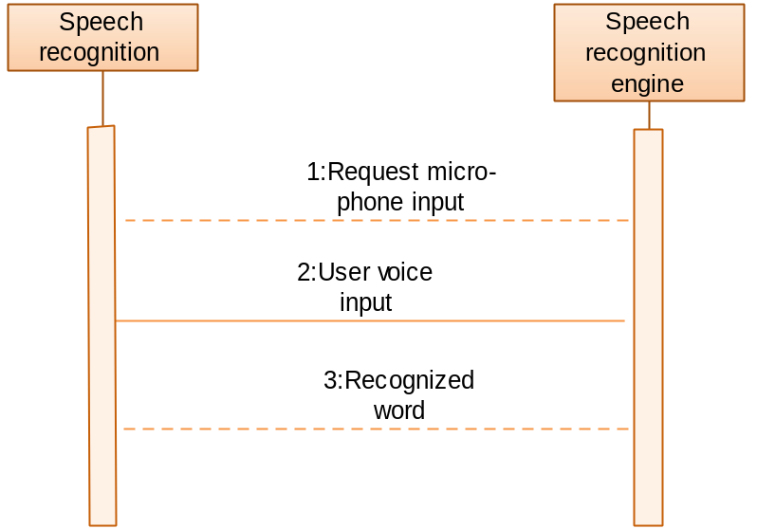
Figure: 3.4 Sequence Diagram for Speech Recognition

3.2.4 Sequence Diagram for Spell Check
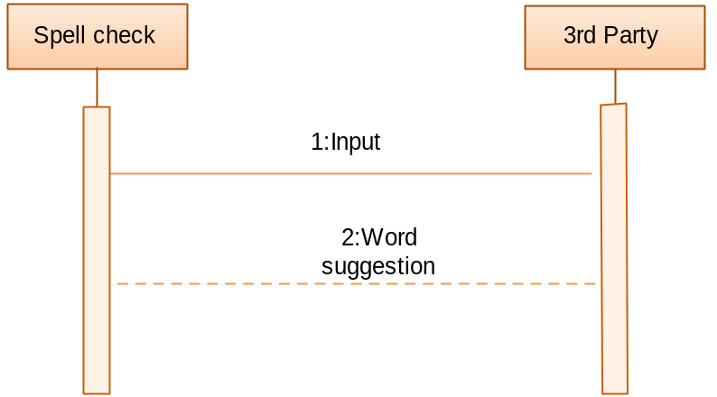
Figure: 3.5 Sequence Diagram for Spell Check

3.3 Entity Relationship Diagram

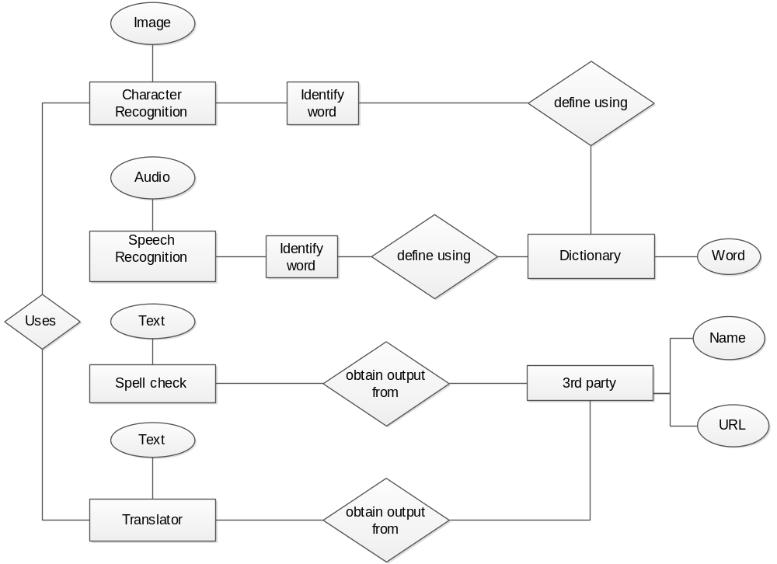

Figure: 3.6 E-R Diagram of System Application

3.4 Class Diagram:

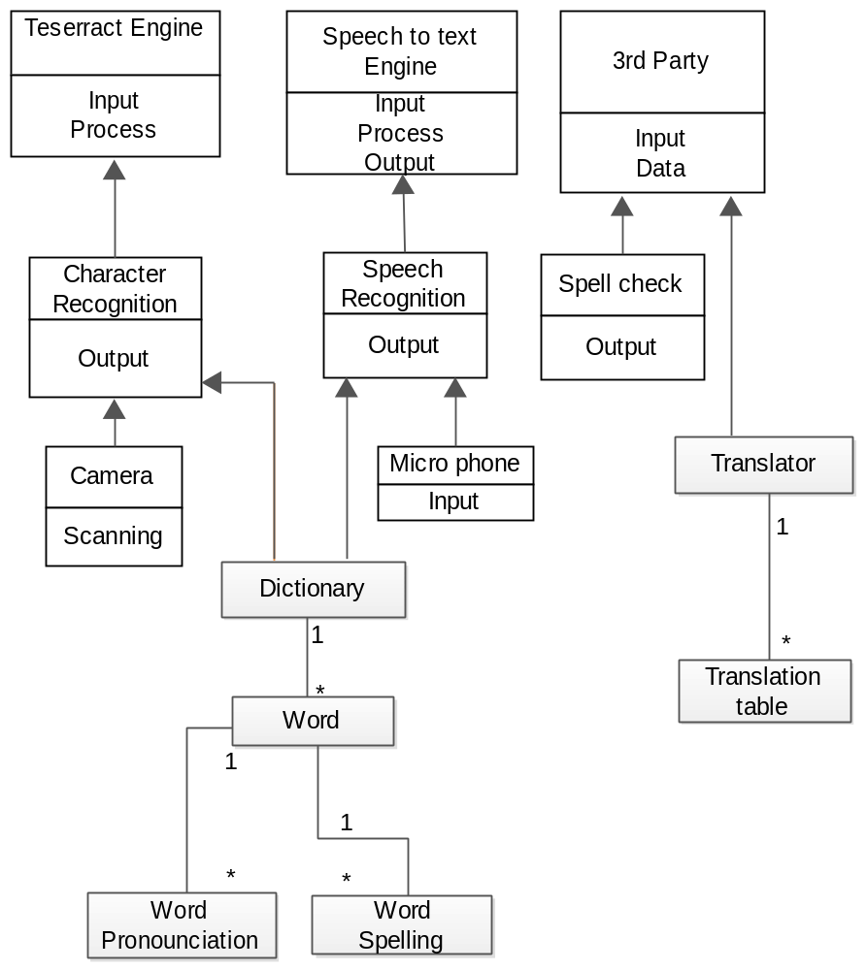

Figure: 3.7 Class Diagram of System Application

3.5 Activity Diagram:

3.5.1 Activity Diagram for System

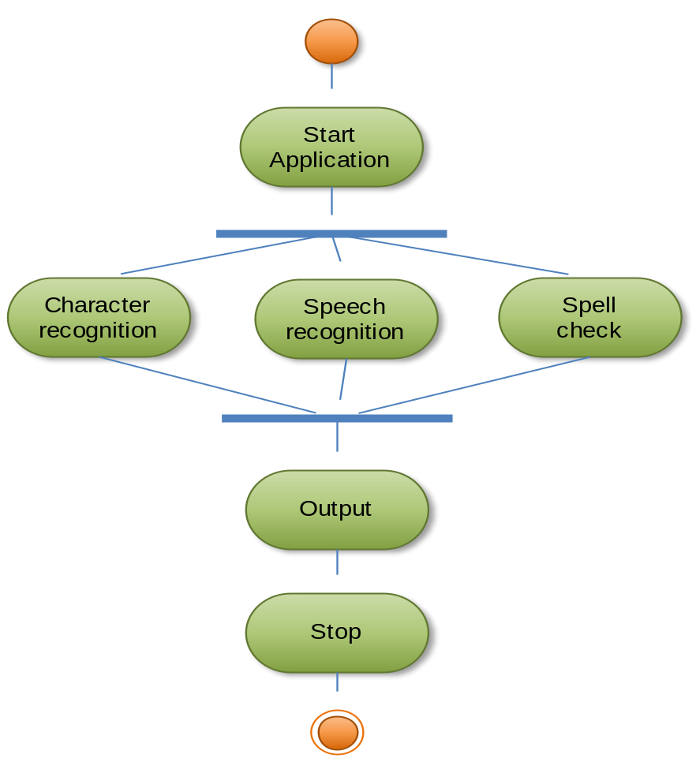

Figure: 3.8 Activity Diagram for System

3.5.2 Activity Diagram for Character Recognition

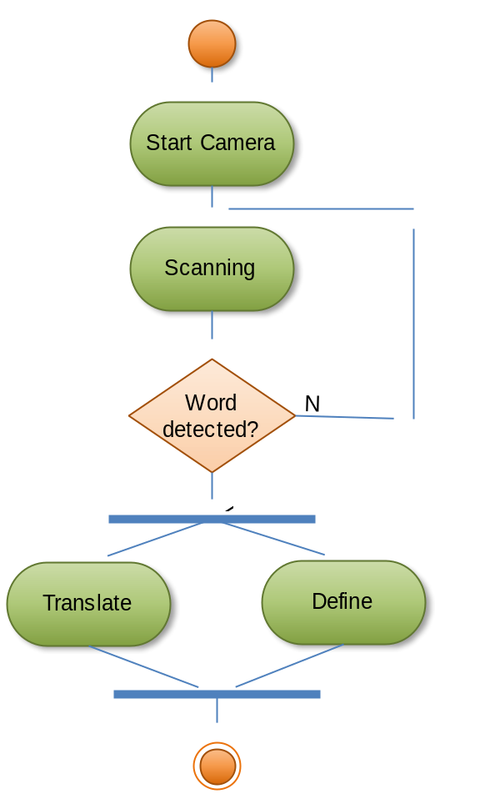
Figure: 3.9 Activity Diagram for Character Recognition

3.5.3 Activity Diagram for Speech Recognition

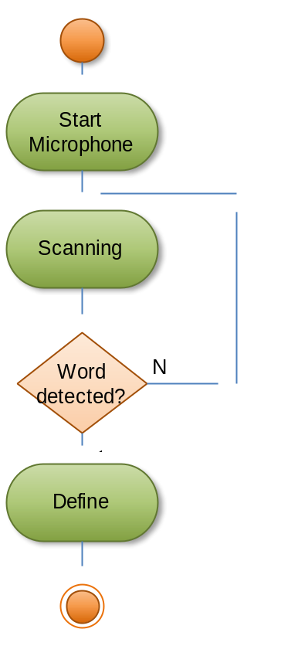
Figure: 3.10 Activity Diagram for Speech Recognition

3.5.4 Activity Diagram for Spell Check

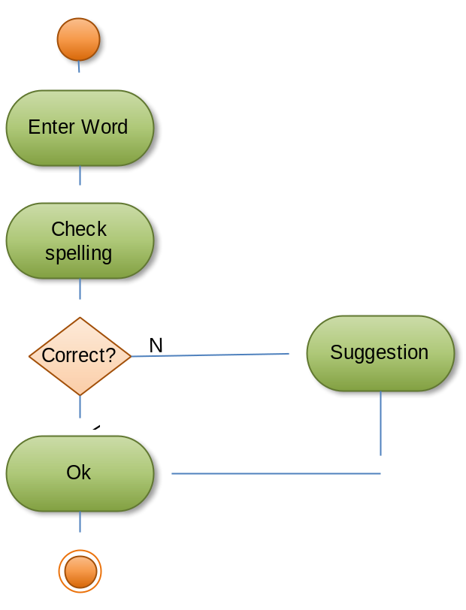
Figure: 3.11 Activity Diagram for Spell Check

3.6 GUI Snapshots:
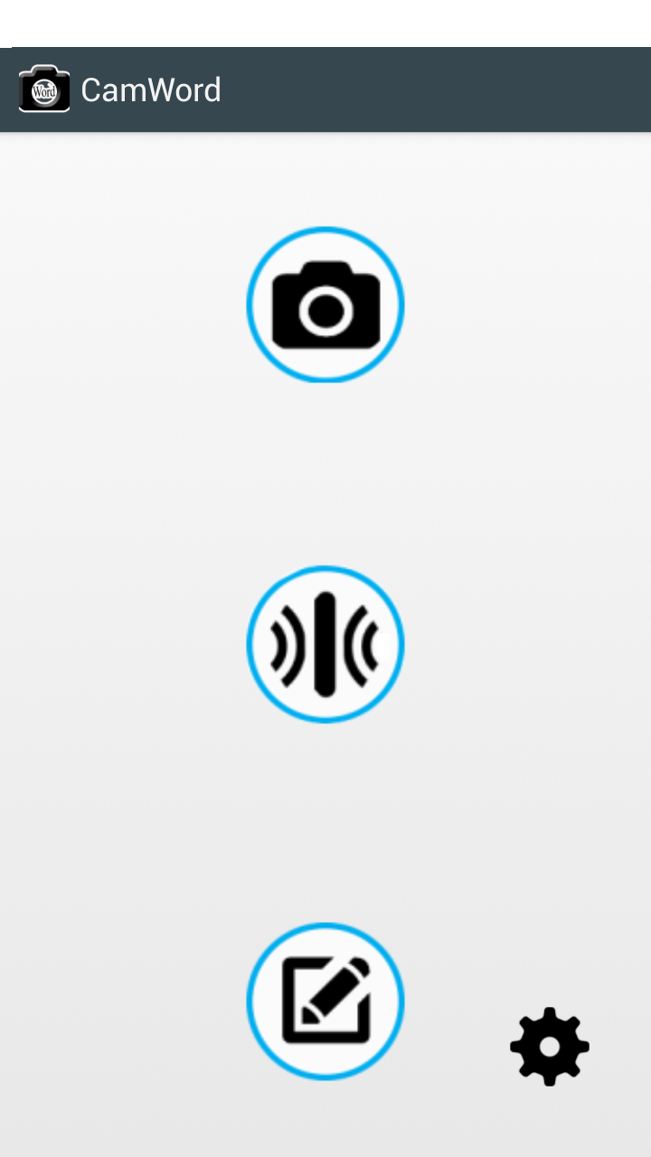
Figure 5.12 GUI for System

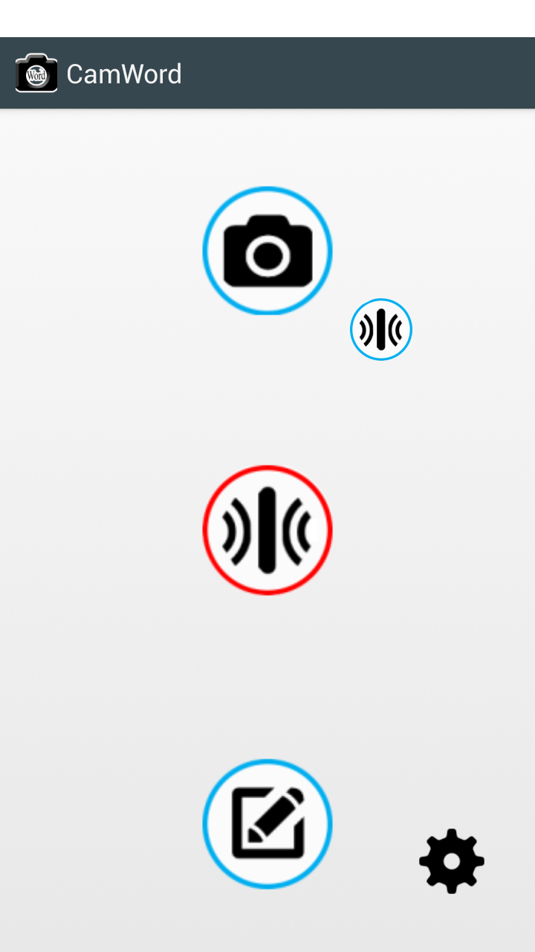
Figure 5.13 GUI for System

Chapter 4:
Requirement Analysis

The process of studying and analyzing the customer and the user needs to arrive at a definition of the problem domain and system requirements.
Objectives
- Discover the boundaries of the new system (or software) and how it must interact with its environment within the new problem domain
- Detect and resolve conflicts between (user) requirements
- Negotiate priorities of stakeholders
- Elaborate system requirements, defined in the requirement specification document, such that managers can give realistic project estimates and developers can design, implement, and test
- Classify requirements information into various categories and allocate requirements to sub-systems
- Evaluate requirements for desirable qualities
There are two kinds of requirements:
Functional Requirements- which say what the system should do or how it should work. Non-Functional Requirements, which say what constraints there are on the system and its development

4.1 User Characteristics:
The users of the system are members and the admin who maintain the system. The members are assumed to have basic knowledge of the mobile and use of Android.

4.2 Hardware Requirements:
This will be an Android phone application, and as such will be designed to interface with the hardware present on the Android phone. There are 4 physical buttons on the phone. The options button will be used specifically in multiple instances to bring up menus, such as in bringing up the ability to add an idea during the idea generation phase.

Supported devices include any Android device with a touch screen and running on the Android OS version 1.6 or greater. This application is specifically designed for newer android mobile phones and tablets, and as a result, Performance is not optimized for smaller, older devices.

Battery life is a product of the hardware and should be considered by the user when using our application, as this is dependent on the device being used.Sound will be supported, and should be turned on at times to experience the full functionality of the application.GPS, Camera, are the product of the hardware and should be considered by the user when using our application, as this is dependent on the device being used.

4.3 Requirements for Development:
Android OS 1.6 is a minimum requirement. Older versions may be able to run the application, but may not be able to support all features and functionality. Internet connectivity should be enabled to provide feedback and access new books. The OS file storage system will be accessed to store user information and maintain persistent user data.
This product will be connecting remotely to a MySQL database that is already set up and is the same one that the edge website connects to. This allows for use in exercises by users of both computers and the phone. The operating system the software runs on will be the operating system the Android phone runs on, which comes with a software framework that will be utilized, including many prepackaged components to do things like create menus, hookup buttons, and other common functions expected of a mobile device

4.3.1 Functional Requirements
- Application must run without failure.
- All data about the Customer must be properly stored in the database.
- Registered user must be able to access all the functionalities from one site.
- System must be able to generate the reports from the data obtained.
4.3.2 Non-Functional Requirements
The non-functional requirement includes those that are implicit and improve the quality of the Application. Better user interface is the key feature of non-functional requirements. The user will ease when interacting with Application in an easy to understand way with providing tips and hints at various stages.

    - Flexibility: The Software should be flexible enough to incorporate the facility to update the values of interest and any transacted amounts as well as leave bounds.
    - Security: The software should provide security to prevent unauthorized access as well as checking to prevent any mal-functioning. We have provided security to our system to prevent unauthorized access.
    - Reliability: Reliability should be assured by carrying out several tests for various test data as well as real life data and the output result should match the actual result.
Application must support the minimum required operating system.
Chapter 5
Coding, Testing and Implementation

5.1 Coding Standards
We follow standard Android (Java) coding conventions. We add a few rules:

Don't Ignore Exceptions
Sometimes it is tempting to write code that completely ignores an exception like this:
voidsetServerPort(String value)
{
try
{
serverPort=Integer.parseInt(value);
} catch(NumberFormatException e) {}
}
You must never do this. While you may think that your code will never encounter this error condition or that it is not important to handle it, ignoring exceptions like above creates mines in your code for someone else to trip over some day. You must handle every Exception in your code in some principled way. The specific handling varies depending on the case.
Anytime somebody has an empty catch clause they should have a creepy feeling. There are definitely times when it is actually the correct thing to do, but at least you have to think about it. In Java you can't escape the creepy feeling. -James Gosling
Acceptable alternatives (in order of preference) are:
- Throw the exception up to the caller of your method.
voidsetServerPort(String value)throwsNumberFormatException
{
serverPort=Integer.parseInt(value);
}
- Throw a new exception that's appropriate to your level of abstraction.
voidsetServerPort(String value)throwsConfigurationException
{
try
{
serverPort=Integer.parseInt(value);
}catch(NumberFormatException e)
{
thrownewConfigurationException("Port "+ value +" is not valid.");
}
}
- Handle the error gracefully and substitute an appropriate value in the catch {} block.
/** Set port. If value is not a valid number, 80 is substituted. */
voidsetServerPort(String value)
{
try
{
serverPort=Integer.parseInt(value);
}catch(NumberFormatException e)
{
serverPort=80; // default port for server
}
}
- Catch the Exception and throw a new RuntimeException. This is dangerous: only do it if you are positive that if this error occurs, the appropriate thing to do is crash.
/** Set port. If value is not a valid number, die. */
voidsetServerPort(String value)
{
try
{
serverPort=Integer.parseInt(value);
}catch(NumberFormatException e)
{
thrownewRuntimeException("port "+ value " is invalid, ", e);
}
}
Note that the original exception is passed to the constructor for RuntimeException. If your code must compile under Java 1.3, you will need to omit the exception that is the cause.
- Last resort: if you are confident that actually ignoring the exception is appropriate then you may ignore it, but you must also comment why with a good reason:
/** If value is not a valid number, original port number is used. */
voidsetServerPort(String value){
try{
serverPort=Integer.parseInt(value);
}catch(NumberFormatException e){
// Method is documented to just ignore invalid user input.
// serverPort will just be unchanged.
}
}

Don't Catch Generic Exception
Sometimes it is tempting to be lazy when catching exceptions and do something like this:
try{
someComplicatedIOFunction(); // may throw IOException
someComplicatedParsingFunction(); // may throw ParsingException
someComplicatedSecurityFunction(); // may throw SecurityException
// phew, made it all the way
}catch(Exception e){ // I'll just catch all exceptions
handleError(); // with one generic handler!
}
You should not do this. In almost all cases it is inappropriate to catch generic Exception or Throwable, preferably not Throwable, because it includes Error exceptions as well. It is very dangerous. It means that Exceptions you never expected (including RuntimeExceptions like ClassCastException) end up getting caught in application-level error handling. It obscures the failure handling properties of your code. It means if someone adds a new type of Exception in the code you're calling, the compiler won't help you realize you need to handle that error differently. And in most cases you shouldn't be handling different types of exception the same way, anyway.
There are rare exceptions to this rule: certain test code and top-level code where you want to catch all kinds of errors (to prevent them from showing up in a UI, or to keep a batch job running). In that case you may catch generic Exception (or Throwable) and handle the error appropriately. You should think very carefully before doing this, though, and put in comments explaining why it is safe in this place.
Alternatives to catching generic Exception:
- Catch each exception separately as separate catch blocks after a single try. This can be awkward but is still preferable to catching all Exceptions. Beware repeating too much code in the catch blocks.
- Refactor your code to have more fine-grained error handling, with multiple try blocks. Split up the IO from the parsing, handle errors separately in each case.
- Rethrow the exception. Many times you don't need to catch the exception at this level anyway, just let the method throw it.
Remember: exceptions are your friend! When the compiler complains you're not catching an exception, don't scowl. Smile: the compiler just made it easier for you to catch runtime problems in your code.

Don't Use Finalizers
Finalizers are a way to have a chunk of code executed when an object is garbage collected.
Pros: can be handy for doing cleanup, particularly of external resources.
Cons: there are no guarantees as to when a finalizer will be called, or even that it will be called at all.
Decision: we don't use finalizers. In most cases, you can do what you need from a finalizer with good exception handling. If you absolutely need it, define a close() method (or the like) and document exactly when that method needs to be called. See InputStream for an example. In this case it is appropriate but not required to print a short log message from the finalizer, as long as it is not expected to flood the logs.

Fully Qualify Imports
When you want to use class Bar from package foo,there are two possible ways to import it:
- import foo.*;
Pros: Potentially reduces the number of import statements.
- import foo.Bar;
Pros: Makes it obvious what classes are actually used. Makes code more readable for maintainers.
Decision: Use the latter for importing all Android code. An explicit exception is made for java standard libraries (java.util.*, java.io.*, etc.) and unit test code (junit.framework.*)

Java Library Rules

There are conventions for using Android's Java libraries and tools. In some cases, the convention has changed in important ways and older code might use a deprecated pattern or library. When working with such code, it's okay to continue the existing style. When creating new components never use deprecated libraries.

Use Javadoc Standard Comments
Every file should have a copyright statement at the top. Then a package statement and import statements should follow, each block separated by a blank line. And then there is the class or interface declaration. In the Javadoc comments, describe what the class or interface does.
/*
* Copyright (C) 2013 The Android Open Source Project
*
* Licensed under the Apache License, Version 2.0 (the "License");
* you may not use this file except in compliance with the License.
* You may obtain a copy of the License at
* http://www.apache.org/licenses/LICENSE-2.0
* unless required by applicable law or agreed to in writing, software
* distributed under the License is distributed on an "AS IS" BASIS,
* WITHOUT WARRANTIES OR CONDITIONS OF ANY KIND, either express or implied.
* See the License for the specific language governing permissions and
* limitations under the License.
*/
packagecom.android.internal.foo;
importandroid.os.Blah;
importandroid.view.Yada;
importjava.sql.ResultSet;
importjava.sql.SQLException;
/**
* Does X and Y and provides an abstraction for Z.
*/
publicclassFoo{
...
}
Every class and nontrivial public method you write must contain a Javadoc comment with at least one sentence describing what the class or method does. This sentence should start with a 3rd person descriptive verb.
Examples:
/** Returns the correctly rounded positive square root of a double value. */
staticdoublesqrt(double a){
...
}
or
/**
* Constructs a new String by converting the specified array of
* bytes using the platform's default character encoding.
*/
publicString(byte[] bytes){
...
}
You do not need to write Javadoc for trivial get and set methods such as setFoo() if all your Javadoc would say is "sets Foo". If the method does something more complex (such as enforcing a constraint or having an important side effect), then you must document it. And if it's not obvious what the property "Foo" means, you should document it.
Every method you write, whether public or otherwise, would benefit from Javadoc. Public methods are part of an API and therefore require Javadoc.
Android does not currently enforce a specific style for writing Javadoc comments, but you should follow the Code Conventions for the Java Programming Language.

Write Short Methods
To the extent that it is feasible, methods should be kept small and focused. It is, however, recognized that long methods are sometimes appropriate, so no hard limit is placed on method length. If a method exceeds 40 lines or so, think about whether it can be broken up without harming the structure of the program.

Define Fields in Standard Places
Fields should be defined either at the top of the file, or immediately before the methods that use them.

Limit Variable Scope
The scope of local variables should be kept to a minimum (Effective Java Item 29). By doing so, you increase the readability and maintainability of your code and reduce the likelihood of error. Each variable should be declared in the innermost block that encloses all uses of the variable.
Local variables should be declared at the point they are first used. Nearly every local variable declaration should contain an initializer. If you don't yet have enough information to initialize a variable sensibly, you should postpone the declaration until you do.
One exception to this rule concerns try-catch statements. If a variable is initialized with the return value of a method that throws a checked exception, it must be initialized inside a try block. If the value must be used outside of the try block, then it must be declared before the try block, where it cannot yet be sensibly initialized:
// Instantiate class cl, which represents some sort of Set
Set s =null;
try{
s =(Set)cl.newInstance();
}catch(IllegalAccessException e){
thrownewIllegalArgumentException(cl +" not accessible");
}catch(InstantiationException e){
thrownewIllegalArgumentException(cl +" not instantiable");
}
// Exercise the set
s.addAll(Arrays.asList(args));
But even this case can be avoided by encapsulating the try-catch block in a method:
SetcreateSet(Class cl){
// Instantiate class cl, which represents some sort of Set
try{
return(Set)cl.newInstance();
}catch(IllegalAccessException e){
thrownewIllegalArgumentException(cl +" not accessible");
}catch(InstantiationException e){
thrownewIllegalArgumentException(cl +" not instantiable");
}
}
...
// Exercise the set
Set s =createSet(cl);
s.addAll(Arrays.asList(args));
Loop variables should be declared in the for statement itself unless there is a compelling reason to do otherwise:
for(inti=0;i< n;i++){
doSomething(i);
}
and
for(Iteratori=c.iterator();i.hasNext();){
doSomethingElse(i.next());
}

Order Import Statements
The ordering of import statements is:
- Android imports
- Imports from third parties (com, junit, net, org)
- java and javax
To exactly match the IDE settings, the imports should be:
- Alphabetical within each grouping, with capital letters before lower case letters (e.g. Z before a).
- There should be a blank line between each major grouping (android, com, junit, net, org, java, javax).
Originally there was no style requirement on the ordering. This meant that the IDE's were either always changing the ordering, or IDE developers had to disable the automatic import management features and maintain the imports by hand. This was deemed bad. When java-style was asked, the preferred styles were all over the map. It pretty much came down to our needing to "pick an ordering and be consistent." So we chose a style, updated the style guide, and made the IDEs obey it. We expect that as IDE users work on the code, the imports in all of the packages will end up matching this pattern without any extra engineering effort.
This style was chosen such that:
- The imports people want to look at first tend to be at the top (android)
- The imports people want to look at least tend to be at the bottom (java)
- Humans can easily follow the style
- IDEs can follow the style
The use and location of static imports have been mildly controversial issues. Some people would prefer static imports to be interspersed with the remaining imports, some would prefer them reside above or below all other imports. Additionally, we have not yet come up with a way to make all IDEs use the same ordering.
Since most people consider this a low priority issue, just use your judgement and please be consistent.

Use Spaces for Indentation
We use 4 space indents for blocks. We never use tabs. When in doubt, be consistent with code around you.
We use 8 space indents for line wraps, including function calls and assignments. For example, this is correct:
Instrumenti=
someLongExpression(that,wouldNotFit, on, one, line);
and this is not correct:
Instrumenti=
someLongExpression(that,wouldNotFit, on, one, line);

Follow Field Naming Conventions
- Non-public, non-static field names start with m.
- Static field names start with s.
- Other fields start with a lower case letter.
- Public static final fields (constants) are ALL_CAPS_WITH_UNDERSCORES.
For example:
publicclassMyClass{
publicstaticfinalint SOME_CONSTANT =42;
publicintpublicField;
privatestaticMyClasssSingleton;
intmPackagePrivate;
privateintmPrivate;
protectedintmProtected;
}

Use Standard Brace Style
Braces do not go on their own line; they go on the same line as the code before them. So:
classMyClass{
intfunc(){
if(something){
// ...
}elseif(somethingElse){
// ...
}else{
// ...
}
}
}
We require braces around the statements for a conditional. Except, if the entire conditional (the condition and the body) fit on one line, you may (but are not obligated to) put it all on one line. That is, this is legal:
if(condition){
body();
}
and this is legal:
if(condition) body();
but this is still illegal:
if(condition)
body(); // bad!

Limit Line Length
Each line of text in your code should be at most 100 characters long.
There has been lots of discussion about this rule and the decision remains that 100 characters is the maximum.
Exception: if a comment line contains an example command or a literal URL longer than 100 characters, that line may be longer than 100 characters for ease of cut and paste.
Exception: import lines can go over the limit because humans rarely see them. This also simplifies tool writing.

Use Standard Java Annotations
Annotations should precede other modifiers for the same language element. Simple marker annotations (e.g. @Override) can be listed on the same line with the language element. If there are multiple annotations, or parameterized annotations, they should each be listed one-per-line in alphabetical order.<
Android standard practices for the three predefined annotations in Java are:
- @Deprecated: The @Deprecated annotation must be used whenever the use of the annotated element is discouraged. If you use the @Deprecated annotation, you must also have a @deprecated Javadoc tag and it should name an alternate implementation. In addition, remember that a @Deprecated method is still supposed to work.
If you see old code that has a @deprecated Javadoc tag, please add the @Deprecated annotation.
- @Override: The @Override annotation must be used whenever a method overrides the declaration or implementation from a super-class.
For example, if you use the @inheritdocsJavadoc tag, and derive from a class (not an interface), you must also annotate that the method @Overrides the parent class's method.
- @SuppressWarnings: The @SuppressWarnings annotation should only be used under circumstances where it is impossible to eliminate a warning. If a warning passes this "impossible to eliminate" test, the @SuppressWarnings annotation must be used, so as to ensure that all warnings reflect actual problems in the code.
When a @SuppressWarnings annotation is necessary, it must be prefixed with a TODO comment that explains the "impossible to eliminate" condition. This will normally identify an offending class that has an awkward interface. For example:
// TODO: The third-party class com.third.useful.Utility.rotate() needs generics
@SuppressWarnings("generic-cast")
List<String>blix=Utility.rotate(blax);
When a @SuppressWarnings annotation is required, the code should be refactored to isolate the software elements where the annotation applies.

Treat Acronyms as Words
Treat acronyms and abbreviations as words in naming variables, methods, and classes. The names are much more readable:
Good | Bad
XmlHttpRequest | XMLHTTPRequest
getCustomerId | getCustomerID
class Html | class HTML
String url | String URL
long id | long ID
Both the JDK and the Android code bases are very inconsistent with regards to acronyms, therefore, it is virtually impossible to be consistent with the code around you. Bite the bullet, and treat acronyms as words.
For further justifications of this style rule, see Effective Java Item 38 and Java Puzzlers Number 68.

Use TODO Comments
Use TODO comments for code that is temporary, a short-term solution, or good-enough but not perfect.
TODOs should include the string TODO in all caps, followed by a colon:
// TODO: Remove this code after the UrlTable2 has been checked in.

Log Sparingly
While logging is necessary it has a significantly negative impact on performance and quickly loses its usefulness if it's not kept reasonably terse. The logging facilities provides five different levels of logging. Below are the different levels and when and how they should be used.
- ERROR: This level of logging should be used when something fatal has happened, i.e. something that will have user-visible consequences and won't be recoverable without explicitly deleting some data, uninstalling applications, wiping the data partitions or reflashing the entire phone (or worse). This level is always logged. Issues that justify some logging at the ERROR level are typically good candidates to be reported to a statistics-gathering server.
- WARNING: This level of logging should used when something serious and unexpected happened, i.e. something that will have user-visible consequences but is likely to be recoverable without data loss by performing some explicit action, ranging from waiting or restarting an app all the way to re-downloading a new version of an application or rebooting the device. This level is always logged. Issues that justify some logging at the WARNING level might also be considered for reporting to a statistics-gathering server.
- INFORMATIVE: This level of logging should used be to note that something interesting to most people happened, i.e. when a situation is detected that is likely to have widespread impact, though isn't necessarily an error. Such a condition should only be logged by a module that reasonably believes that it is the most authoritative in that domain (to avoid duplicate logging by non-authoritative components). This level is always logged.
- DEBUG: This level of logging should be used to further note what is happening on the device that could be relevant to investigate and debug unexpected behaviors. You should log only what is needed to gather enough information about what is going on about your component. If your debug logs are dominating the log then you probably should be using verbose logging.
This level will be logged, even on release builds, and is required to be surrounded by an if (LOCAL_LOG) or if (LOCAL_LOGD) block, where LOCAL_LOG[D] is defined in your class or subcomponent, so that there can exist a possibility to disable all such logging. There must therefore be no active logic in an if (LOCAL_LOG) block. All the string building for the log also needs to be placed inside the if (LOCAL_LOG) block. The logging call should not be re-factored out into a method call if it is going to cause the string building to take place outside of the if (LOCAL_LOG) block.
There is some code that still says if (localLOGV). This is considered acceptable as well, although the name is nonstandard.
- VERBOSE: This level of logging should be used for everything else. This level will only be logged on debug builds and should be surrounded by an if (LOCAL_LOGV) block (or equivalent) so that it can be compiled out by default. Any string building will be stripped out of release builds and needs to appear inside the if (LOCAL_LOGV) block.

Be Consistent
Our parting thought: BE CONSISTENT. If you're editing code, take a few minutes to look at the code around you and determine its style. If they use spaces around their if clauses, you should too. If their comments have little boxes of stars around them, make your comments have little boxes of stars around them too.
The point of having style guidelines is to have a common vocabulary of coding, so people can concentrate on what you're saying, rather than on how you're saying it. We present global style rules here so people know the vocabulary. But local style is also important. If code you add to aa file looks drastically different from the existing code around it, it throws readers out of their rhythm when they go to read it. Try to avoid this.

Java tests Style Rules

Follow Test Method Naming Conventions
When naming test methods, you can use an underscore to seperate what is being tested from the specific case being tested. This style makes it easier to see exactly what cases are being tested.
For example:
testMethod_specificCase1 testMethod_specificCase2
voidtestIsDistinguishable_protanopia(){
ColorMatchercolorMatcher=newColorMatcher(PROTANOPIA)
assertFalse(colorMatcher.isDistinguishable(Color.RED,Color.BLACK))
assertTrue(colorMatcher.isDistinguishable(Color.X,Color.Y))
}

5.2 Software Testing

5.2.1 Overview of Test Method:

Black Box Testing
The technique of testing without having any knowledge of the interior workings of the application is Black Box testing. The tester is oblivious to the system architecture and does not have access to the source code. Typically, when performing a black box test, a tester will interact with the system's user interface by providing inputs and examining outputs without knowing how and where the inputs are worked upon.

White Box Testing
White box testing is the detailed investigation of internal logic and structure of the code. White box testing is also called glass testing or open box testing. In order to perform white box testing on an application, the tester needs to possess knowledge of the internal working of the code.
The tester needs to have a look inside the source code and find out which unit/chunk of the code is behaving inappropriately.

Grey Box Testing
Grey Box testing is a technique to test the application with limited knowledge of the internal workings of an application. In software testing, the term the more you know the better carries a lot of weight when testing an application.
Mastering the domain of a system always gives the tester an edge over someone with limited domain knowledge. Unlike black box testing, where the tester only tests the application's user interface, in grey box testing, the tester has access to design documents and the database. Having this knowledge, the tester is able to better prepare test data and test scenarios when making the test plan.

5.2.2 Modules of Testing:
The Android testing framework, an integral part of the development environment, provides an architecture and powerful tools that help you test every aspect of your application at every level from unit to framework.
The testing framework has these key features:
- Android test suites are based on JUnit. You can use plain JUnit to test a class that doesn't call the Android API, or Android's JUnit extensions to test Android components. If you're new to Android testing, you can start with general-purpose test case classes such as AndroidTestCase and then go on to use more sophisticated classes.
- The Android JUnit extensions provide component-specific test case classes. These classes provide helper methods for creating mock objects and methods that help you control the lifecycle of a component.
- Test suites are contained in test packages that are similar to main application packages, so you don't need to learn a new set of tools or techniques for designing and building tests.
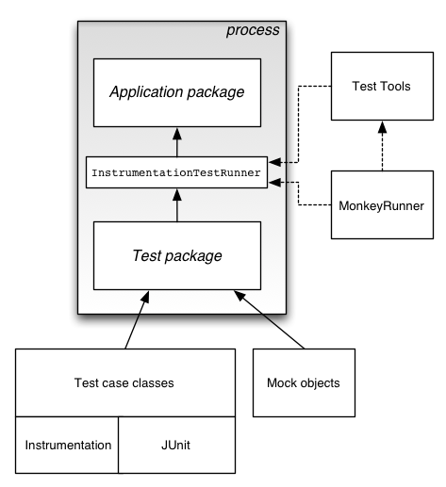
The SDK tools for building and tests are available in Eclipse with ADT, and also in of the application under test and use this information to automatically create the build files, manifest file, and directory structure for the test package.
- The SDK also provides monkeyrunner, an API for testing devices with Python programs, and UI/Application Exerciser Monkey, a command-line tool for stress-testing UIs by sending pseudo-random events to a device.

Testing from Eclipse with ADT
This topic explains how create and run tests of Android applications in Eclipse with ADT. Before you read this topic, you should read about how to create an Android application with the basic processes for creating and running applications with ADT, as described in Managing Projects from Eclipse and Building and Running from Eclipse. You may also want to read Testing Fundamentals, which provides an overview of the Android testing framework.
ADT provides several features that help you set up and manage your testing environment effectively:
- It lets you quickly create a test project and link it to the application under test. When it creates the test project, it automatically inserts the necessary <instrumentation> element in the test package's manifest file.
- It lets you quickly import the classes of the application under test, so that your tests can inspect them.
- It lets you create run configurations for your test package and include in them flags that are passed to the Android testing framework.
- It lets you run your test package without leaving Eclipse. ADT builds both the application under test and the test package automatically, installs them if necessary to your device or emulator, runs the test package, and displays the results in a separate window in Eclipse.

Testing from Other IDEs
This document describes how to create and run tests directly from the command line. You can use the techniques described here if you are developing in an IDE other than Eclipse or if you prefer to work from the command line. This document assumes that you already know how to create a Android application in your programming environment. Before you start this document, you should read the topic Testing Fundamentals, which provides an overview of Android testing.
If you are developing in Eclipse with ADT, you can set up and run your tests directly in Eclipse. For more information, please read Testing from Eclipse with ADT.

- Activity Testing
Activity testing is particularly dependent on the Android instrumentation framework. Unlike other components, activities have a complex lifecycle based on callback methods; these can't be invoked directly except by instrumentation. Also, the only way to send events to the user interface from a program is through instrumentation.

- Service Testing

Android provides a testing framework for Service objects that can run them in isolation and provides mock objects. The test case class for Service objects is ServiceTestCase. Since the Service class assumes that it is separate from its clients, you can test a Service object without using instrumentation.

- Content Provider Testing
Content providers, which store and retrieve data and make it accessible across applications, are a key part of the Android API. As an application developer you're allowed to provide your own public providers for use by other applications. If you do, then you should test them using the API you publish

- Accessibility Testing

Testing is an important part of making your application accessible to users with varying abilities. Following design and development guidelines for accessibility are important steps toward that goal, but testing for accessibility can uncover problems with user interaction that are not obvious during design and development.

- UI Testing
In addition to unit testing the individual components that make up your Android application (such as activities, services, and content providers), it is also important that you test the behavior of your application’s user interface (UI) when it is running on a device. UI testing ensures that your application returns the correct UI output in response to a sequence of user actions on a device, such as entering keyboard input or pressing toolbars, menus, dialogs, images, and other UI controls.
Functional or black-box UI testing does not require testers to know the internal implementation details of the app, only its expected output when a user performs a specific action or enters a specific input. This approach allows for better separation of development and testing roles in your organization.
One common approach to UI testing is to run tests manually and verify that the app is behaving as expected. However, this approach can be time-consuming, tedious, and error-prone. A more efficient and reliable approach is to automate the UI testing with a software testing framework. Automated testing involves creating programs to perform testing tasks (test cases) to cover specific usage scenarios, and then using the testing framework to run the test cases automatically and in a repeatable manner.
5.2.3 Testing Strategy:
Various elements of an effective mobile application testing strategy are considered in this section. Recommendations in this section are based onTCS’extensive experience in developing and testing scores of mobile applications.

SelectingTarget Devices

Target devices for testing a mobile application should balance the need to use a representative sample of the expected device population with the need to optimize duration and cost of testing.

Simulators vs. Physical Devices

Use of device simulators can be highly effective in the early stages of product development when features are under development. Simulators are useful to familiarize the test team with various application features.

Figure illustrates various conditions under which testing with simulators and real devices can be effective. Simulators can be effectively used for testing basic application functionality.Testing on physical devices is essential to understanding application behavior such as touch response and user experience. Stable, defect-free (based on simulator testing) features can then be tested on physical devices. Device usage can be optimized by distributing test cases across various types of devices.
Note that this strategy requires that the test tools being used support testing with simulators as well as devices.

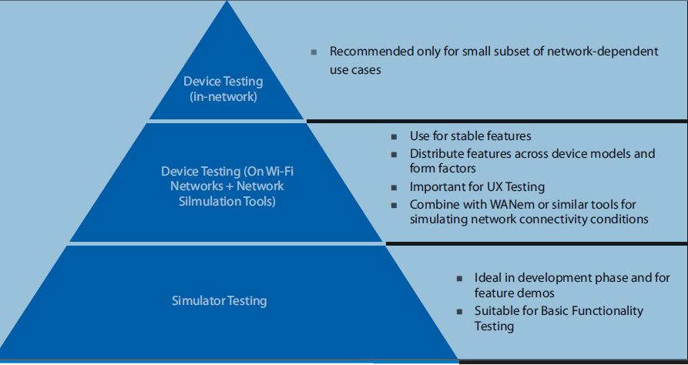
Conditions for Testing with Devices / Simulators and Different Connectivity Options

Device Model Selection

Key factors in deciding specific device models for testing are –

In OS Version – Applications should be tested on all major OS versions in the current installed base. For Android devices, OS distribution of various Android versions provided by Google at http://developer.android.com/about/dashboards/index.html can be used to determine the mix of Android versions to be targeted

Form Factor – Applications may behave differently (especially in terms of user experience) on smartphones and tablets. If the test application supports both smartphones and tablets, it should be tested on both form factors

Display Density –The screen size and screen resolution of a device (aka display density) can also affect application user experience (e.g. look and feel of UI, rendering of web pages). Device models selected for testing should include a mix of different display densities.

A variety of other factors (keyboard, CPU type, memory) can affect specialized applications that rely on specific device features and should be taken into account when necessary.

When testing enterprise applications, a user survey or device model data from internal systems can be a good source of information to determine the mix of target devices for testing

Connectivity Options

Almost all applications rely on network connectivity to provide useful functionality. In test environments, Wi-Fi networks can be easy to set up and can be cost effective, unlike cellular connectivity that can be both unreliable and expensive.

Conclusion

Smartphones are common nowadays, smartphones are not just phones they have become our part of life. Form finding a route to shopping we depend on smartphone apps. Android is most celebrated operating system in smartphones. Our application is an android based application.
Our application is called CamWord, It has three modules:
- Character Recognition (OCR)
- Speech Recognition
- Spell Checker
Character Recognition module identify word from text written either physically or from any other device screen, this word is asked for translation or definition and output is given based on user selection.
Speech Recognition identify word form user speech and provide its definition in an Android Toast Message. Spell check is additional module that just check user word spelling. Our application will help many while they reading or writing, this application will provide enhance experience to user and also save his/her time.

References

[1.] Android. (n.d.). Web site: http://www.Android.com/.

[2.] Android Architecture. Website:
http://www.edureka.in/blog/beginners-guide-android-architecture/

[3.] Android Developers. 2015. [Internet]. Available from:
http://developer.android.com/guide/topics/fundamentals.html

[4.] Android Developers. 2015. [Internet]. Available from:
http://developer.android.com/about/index.html

